**Assignment 1**

public class Rectangle {

    private int length;

    private int width;

    public Rectangle(int length, int width) {

        this.length = length;

        this.width = width;

    }

    public int area() {

        return length * width;

    }

    public static void main(String[] args) {

        Rectangle rectangle1 = new Rectangle(5, 10);

        Rectangle rectangle2 = new Rectangle(7, 3);

        if(rectangle1.area() > rectangle2.area()) {

            System.out.println("Rectangle 1 > Rectangle 2");

        } else if(rectangle1.area() < rectangle2.area()) {

            System.out.println("Rectangle 1 < Rectangle 2");

        } else{

            System.out.println("They are equal!");

        }

    }

}

**OUTPUT:**

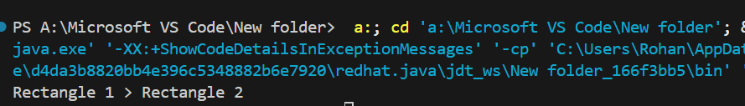

**Assignment 2**

public class BankAccount {

    String accHolderName;

    int accNumber;

    int balance;

    public BankAccount(String accHolderName, int accNumber, int balance) {

        this.accHolderName = accHolderName;

        this.accNumber = accNumber;

        this.balance = balance;

    }

    public String getAccHolderName() {

        return accHolderName;

    }

    public int getAccNumber() {

        return accNumber;

    }

    public int getBalance() {

        return balance;

    }

    public void setAccHolderName(String accHolderName) {

        this.accHolderName = accHolderName;

    }

    public void setAccNumber(int accNumber) {

        this.accNumber = accNumber;

    }

    public void setBalance(int balance) {

        this.balance = balance;

    }

    public int deposit(int amount) {

        if (amount > 0) {

            balance += amount;

            return balance;

        } else {

            System.out.println("Deposit amount must be positive.");

            return balance;

        }

    }

    public int withdraw(int amount) {

        if (amount > 0 && amount <= balance) {

            balance -= amount;

            return balance;

        } else {

            System.out.println("Insufficient or invalid funds.");

            return balance;

        }

    }

    public void display(){

        System.out.println("Account Holder: " + accHolderName);

        System.out.println("Account Number: " + accNumber);

        System.out.println("Current Balance: " + balance);

    }

    public static void main(String[] args) {

        BankAccount account = new BankAccount("John Doe", 123456, 1000);

        account.display();

        account.deposit(500);

        account.withdraw(200);

        account.display();

        account.withdraw(1500);

        account.deposit(-100);

        account.display();

    }

}

**OUTPUT:**

